Patient Participation Meeting
Type of meeting: Formal Clinical Meeting |  |  | Facilitator: | Pauline Woodrow
Note taker:
Nazmeen Khan
Attendees:
Pauline Woodrow, Nazmeen Khan
Kalsoom Bibi
Renata Dziama
Dani Mistry
Araf Alam
Dr A Azam
Dr S R Azam
Dr Jahan Azam

Agenda
Apologies |  |  | SN |  | 5
Discussion:
Sofia Iqbal – PPG Member Saadat Khan PPG Chair, Iqra M Hussain PPG Member.

Minutes from previous meeting |  | PW |  | 5
 | Discussion: Previous Meeting minutes discussed. Gluten Free products stopped on repeats, no problems reported. PPG members all agreed that using pictures & clocks for LD patients, however they suggested this may be a good idea if we used it for patients whose first language is not English
 | Conclusions:
 | Action items: To look at all other appointment letters |  | Person responsible:  Nazmeen Khan |  | Deadline:  31.05.2017

Complaints |  | PW |  | 5
 | Discussion: Summary of complaints discussed.

SEA’s |  | SN | 5
 | Discussion: Summary of Significant Events Discussed

Suggestions
 | PPG members suggested that we put arrows in the corridor so patients know the way out.
 | Conclusions: This will make it easier for patients to identify the way out, especially patients who are illiterate and unable to read English.
 | Action items:  To laminate arrows and display in the corridor. |  | Person responsible:  Nazmeen Khan |  | Deadline:  31.05.2017

Hospital Reminder Service |  |  |  | 5
 | Discussion: Discussion: Pauline explained that the hospital have a reminder service. There are posters in the waiting area, with contact details. Contact number is 01274 274274. Once you contact the hospital and register, patients will receive a text message reminder for your hospital appointments. This will hopefully decrease hospital DNA’s
 | Conclusions: Access should improve, patients will not return to the surgery and ask for a re-referral
 | Action items:  Posters displayed in waiting area, all patients have been text the number to set up hospital reminder service |  | Person responsible:  Nazmeen Khan |  | Deadline:  28.02.2017

Carers 5
Discussion: Discussion on Carers. Pauline explained that we need to ensure all our carers are registered, whether they are paid or unpaid, once registered the practice will refer them to the carer’s connection. The carer’s connection helps the carer with all aspects of caring e.g. benefits, activities and offers a range of sessions for the carer. Once a year there is a grant available for carers to apply for. The carer is also entitled to a free Carers health check and seasonal influenza at the practice. Carers are busy looking after others and tend to forget about themselves. See Appendix 5
 | Conclusions: PPG members to promote this in the community.
 | Action items:  Display in Reception with carers registration card. Invite carers for an annual health check | Person responsible:  PPG Members & Practice frontline staff.  Assistant Manager to delegate. | Deadline:  31.05.2017

Vulnerable Patients |  |  |  | 5
 | Discussion: Prescription ordering at the surgery changed some time ago. There is not one rule for all. The practice has a policy in place for vulnerable adults/children. Vulnerable patients can delegate a member of the family or a pharmacy to order medication on their behalf. Vulnerable adults/children include patients with Dementia, Frailty, elderly, Learning disability, mobility issues, Deaf patients, Blind patients etc. The practice assesses each case individually. See Appendix 1
 | Conclusions: PPG members in agreement with policy.
 | Action items:  To ensure all patients who are vulnerable are coded so they do not have a problem ordering/obtaining medication |  | Person responsible:  Office Manager / Assistant Manager |  | Deadline:  Ongoing

Opening Times |  |  |  | 5
 | Discussion: Pauline discussed change to Practice opening times. The surgery now closes at 6pm instead of 6.30pm.
 | Practice Website/ posters have been updated to reflect this change. See Appendix 6
 | Conclusions: Patients have been made aware.
 | Action items:  Changes already made |  | Person responsible:  Nazmeen Khan / George Telford |  | Deadline:  Complete
Pharmacy First |  |  |  | 5
 | Discussion: Pauline explained to PPG group that the pharmacy first scheme for minor ailments will be ceasing at the end of May (31.05.2017) due to funding. See Appendix 4
 | Conclusions: It was discussed that it took long enough training patients to attend the pharmacy for minor ailments! The patients understood the reasoning behind why this is being stopped.
 | Action items:  Inform practice staff not to direct patients to the pharmacy. Text patients informing them that this service will be ceased at the end of May |  | Person responsible:  Nazmeen Khan |  | Deadline:  31.05.2017
New HCA Apprenticeship |  |  |  | 5
 | Discussion: We have employed a trainee HCA. This will improve access and waiting times for patients who need new patient health checks, blood tests, ECG, ear syringing, wound management and Bradford beating diabetes check.
 | Conclusions: Improving Access for patients
 | Action items:  We will inform practice staff once she has been signed off for each course. |  | Person responsible:  Pauline Woodrow |  | Deadline:  Ongoing
 |  |  |  | 5
Online Figures
Discussion: Nazmeen Khan explained that the online access figures have increased from 18.6% in December to 27.02.2017 to 21.1%
 | Conclusions: Practice staff and PPG members to promote online access. This will have a knock on effect eventually and cut waiting times on the phone and queuing on the front desk. See Appendix 8
 | Action items:  All practice staff to promote online , PPG members to promote online services in the community |  | Person responsible:  Nazmeen Khan |  | Deadline:  Ongoing
DNA |  |  |  | 5
 | Discussion: DNA figures discussed with PPG members. See DNA Appendix 2
 | Conclusions: The figures are not going down. Practice to change policy to allow patients to text and cancel their appointments
 | Action items:  Next figures to include how many minutes of clinical time lost.  Practice to change policy to allow patients to text and cancel their appointments |  | Person responsible:  Nazmeen Khan  Nazmeen Khan |  | Deadline:  Ongoing  30.04.2017

Weight Loss Programme |  |  |  | 5
 | Discussion: There are two new weight management services that families can self-refer or ask gp for a referral.
ABL Adult Weight Management) criteria is Adults aged >18, living in the Bradford metropolitan council, with a BMI 25 – 35 ( or 40 with no co-morbidities)
FAB (Family Weight Management) criteria Any school aged child 5 (attending reception) – 17 and there family/ parents/carers, living in the Bradford metropolitan council, BMI 91st up to and including the 98th centile.
 | Conclusions: PPG members liked the idea that patients can self-refer. Posters in the waiting area. See Appendix 3
 | Action items:  Inform all practice clinicians & staff of referral process and criteria should any patient request a referral. |  | Person responsible:  Pauline Woodrow |  | Deadline:  Ongoing

Sanctuary at Mind |  |  |  | 5
 | Discussion: New service Sanctuary at mind. This is a non-clinical place of safety where experienced staff can support visitors experiencing acute mental distress or crisis. Referrals made through the first response triage system. The service is open 6pm -1am seven days a week. Taxis are often provided by Mind. See Appendix??
 | Conclusions:
 | Action items:  Posters displayed in the waiting room |  | Person responsible:  Nazmeen Khan |  | Deadline:  complete
Warm Home Healthy People |  |  |  | 5
 | Discussion: Warm Homes healthy people programme, patients can join this programme and get free winter accessories (blankets, scarves, mugs, gloves etc.), free debt advice, free access to food banks, free home improvements. See Appendix 7
 | Conclusions: PPG members happy that our practice is sharing this information with patients as a lot of people struggle to keep warm and heat their homes.
 | Action items:  Flyers put our in reception area. We had a gentleman from this programme come into the practice to promote this programme. |  | Person responsible:  Pauline Woodrow |  | Deadline:  Ongoing
Inspired neighbourhoods |  |  |  | 5
 | Discussion: Inspired neighbourhoods –Advice4All.Leaflets and information shared. They offer help with benefits, disabled/ill and have been made fit for work, problems with landlords, gas, electric arrears, and debt issues. See Appendix 9
 | They are based in three different locations. BD2, BD5, BD10. No need for appointments – drop in.
 | Conclusions:
 | Action items:  Leaflets displayed in reception area. |  | Person responsible:  Nazmeen Khan |  | Deadline:  01.03.2017
Seasonal Influenza |  |  |  | 5
 | Discussion: Pauline discussed seasonal influenza will be ending on 31.03.2017. Pauline asked the PPG members to let the community know that if they have not had the flu vaccination to come in and get the vaccination
 | Conclusions: Practice to text all patients who have not had a flu vaccination. PPG to talk to patients in the community.
 | Action items:  Practice to text all patients who have not had a flu vaccination. PPG to talk to patients in the community. |  | Person responsible:  Nazmeen Khan |  | Deadline:  Ongoing
Over the counter Medication |  |  |  | 5
 | Discussion: PPG group were shown a list of medications that the GP will no longer be prescribing medications that can be bought over the counter. CCG& Practice initiative. Promoting self-care. See Appendix 10
 | Conclusions: PPG was negative about this list saying not all patients can afford it, however some PPG members did not know that the pharmacist is able to advise them on which medication they can take.
 | Action items:  Clinicians are all aware that medications that can bought otc should not be prescribed |  | Person responsible:  Clinicians @ practice |  | Deadline:  Ongoing
GP NHS Survey and Practice Survey |  |  |  | 5
Discussion: GP NHS survey will be going out to patients in the next few weeks. Please ask patients in the community to return there surveys and if they require help they can bring their surveys into surgery, and a member of the team will help them to complete the survey

The Practice Surveys were discussed and agreed with the PPG
 | Conclusions: Text all patients to inform them that the GP survey will be sent out and that if they need help to complete they can bring them to surgery. Posters displayed in the waiting room. PPG members to promote in the community.
 | Action items:  Text all patients to inform them that the GP survey will be sent out and that if they need help to complete they can bring them to surgery. Posters displayed in the waiting room. PPG members to promote in the community.  Practice Survey to take place. Results & actions agreed with staff and PPG members before the end of March 2017 |  | Person responsible:  Nazmeen Khan |  | Deadline:  01.03.2017  29/3/2017
AOB |  |  |  | 5
 | Discussion: Renata has agreed to do a Polish Day stall at the practice. She will be providing information about the practice and will be available to help and chat to the Polish population .
 | Conclusions:
 | Action items:  To book a stall. |  | Person responsible:  Pauline Woodrow |  | Deadline:  April/May 2017
 | AOB Discussion: Pauline discussed ETP. Electronic Transfer of Prescriptions, this means that if a patient has a nominated pharmacy prescriptions can be sent electronically. This will stop prescriptions going missing and queues at the front desk. This will be a quicker efficient service for the patients and pharmacist.
 | Conclusions:
 | Action items:  To agree a date with CCHG to go live. |  | Person responsible:  Pauline Woodrow |  | Deadline:  Ongoing
Date & time of next meeting |  |  |  | 5
 | Discussion: Date of next meeting 29/3/2017 10.05.2017 @10.30am
 | Action items:  To be added to practice calendar, invites to be sent 2 weeks before meeting. |  | Person responsible:  Administrator |  | Deadline:  Ongoing

Appendix 1
Parkside Medical Practice –
Patients Ordering Repeat Medication
This information is to support patients who may be vulnerable and/ or have additional needs, who will require additional assistance to order their repeat medication, either from the practice or from a pharmacy. A person who may require assistance is an individual who is at risk of being unable to order or manage their own medication supplies due to life circumstances such as age, mental illness or capacity. Patients who may require additional assistance to manage their medication ordering, either from the practice or from a pharmacy, may be those patients who have or are:
• Elderly housebound/ socially isolated
• Palliative care
• Serious mental health issues
• Learning disabilities
The identified group of patients may require additional assistance from the Practice or from a community pharmacy to order their regular medication.
If you fit into this criteria please speak to the Receptionist or your local Pharmacist and we will endeavour to help solve and help your situation.
Thank you
Pauline Woodrow Practice Manager
Action to be taken from policy above

Should a member of staff or pharmacy identify patients who may require additional assistance from the Practice (i.e. let can order over the telephone) or ask a community pharmacy to order their regular medication please ensure that this written on the reminders in S1. Should the next member of staff come across this request they will then look at the reminders and ensure that the request is actioned. Ensure the reminder is set to HIGH priority.

Appendix 2

DNA REPORT 2017
April | 120
May | 125
June | 167
July | 159
August | 158
September | 231
October | 234
November | 175
December | 224
January | 229
February | 207
March | 177

Appendix 3

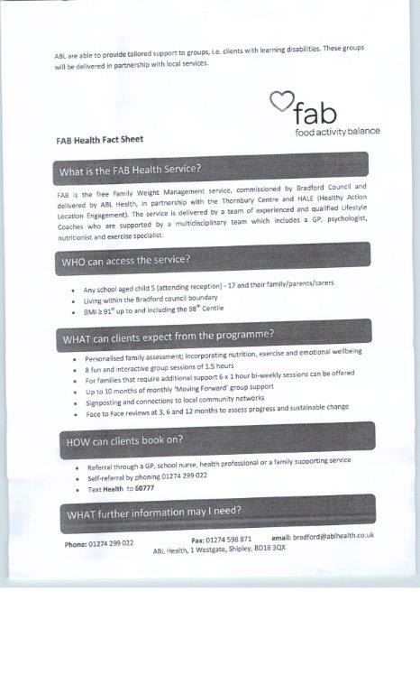
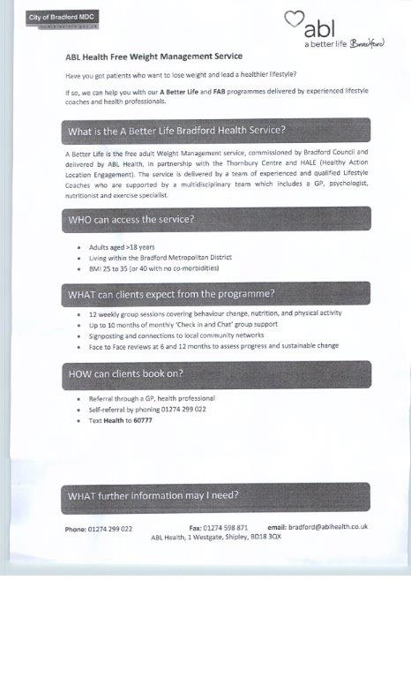

Appendix 4
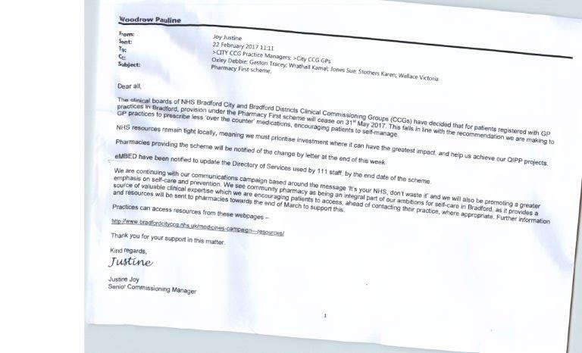

Appendix 5

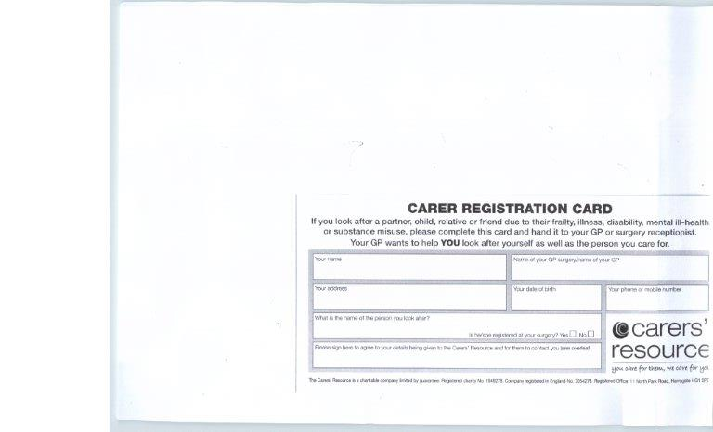
Appendix 6

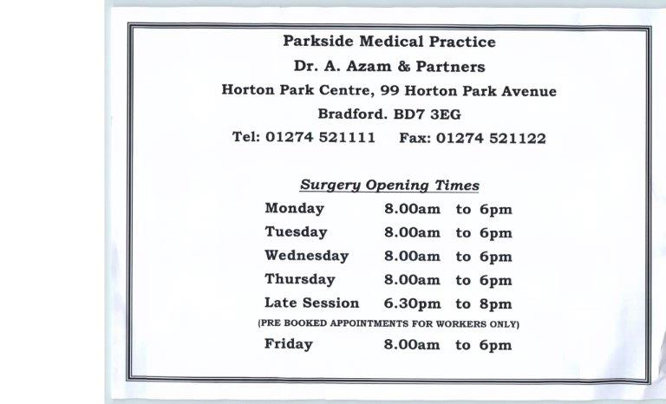

Appendix 7
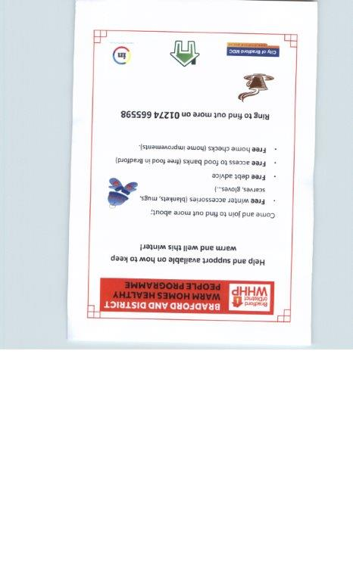

Appendix 8

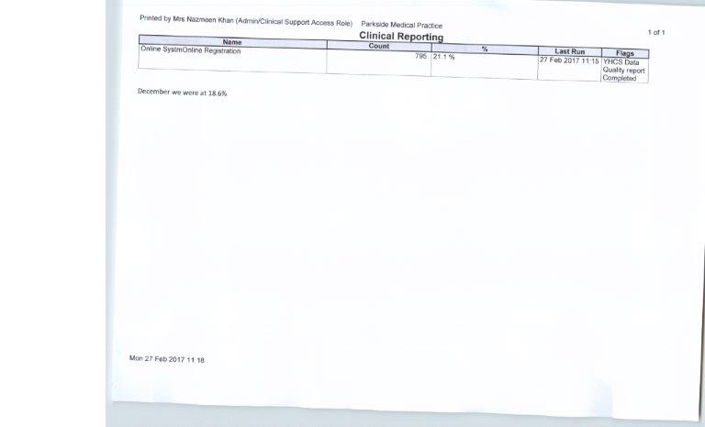

Appendix 9

Appendix 10

Reduction of prescribing of OTC medicines
These are the conditions we are proposing patients should self manage:
- Athletes foot
- Backache
- Blocked nose
- Cold sores
- Common cold
- Conjunctivitis
- Constipation
- Coughs
- Diarrhoea
- Dry skin
- Ear wax
- Eczema (mild)
- Haemorrhoids
- Hay fever
- Head lice
- Heartburn
- Indigestion
- Infant colic
- Insect bites/stings
- Mouth ulcers
- Nappy rash
- Oral thrush
- Short term pain
- Scabies
- Sore throat
- Sprains and strains
- Teething
- Temperature or fever
- Threadworms
- Vaginal thrush
- Verruca’s or warts

